***Devoops***

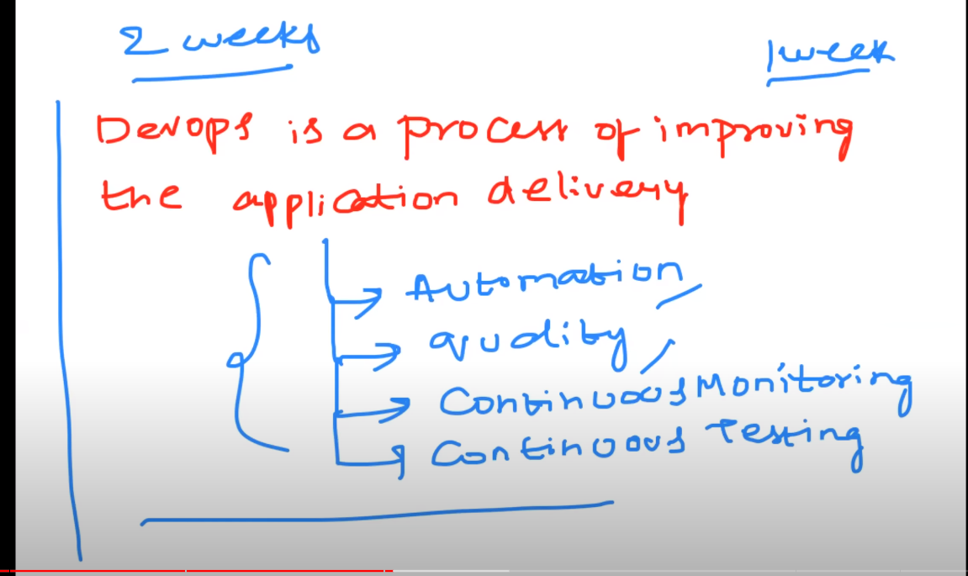

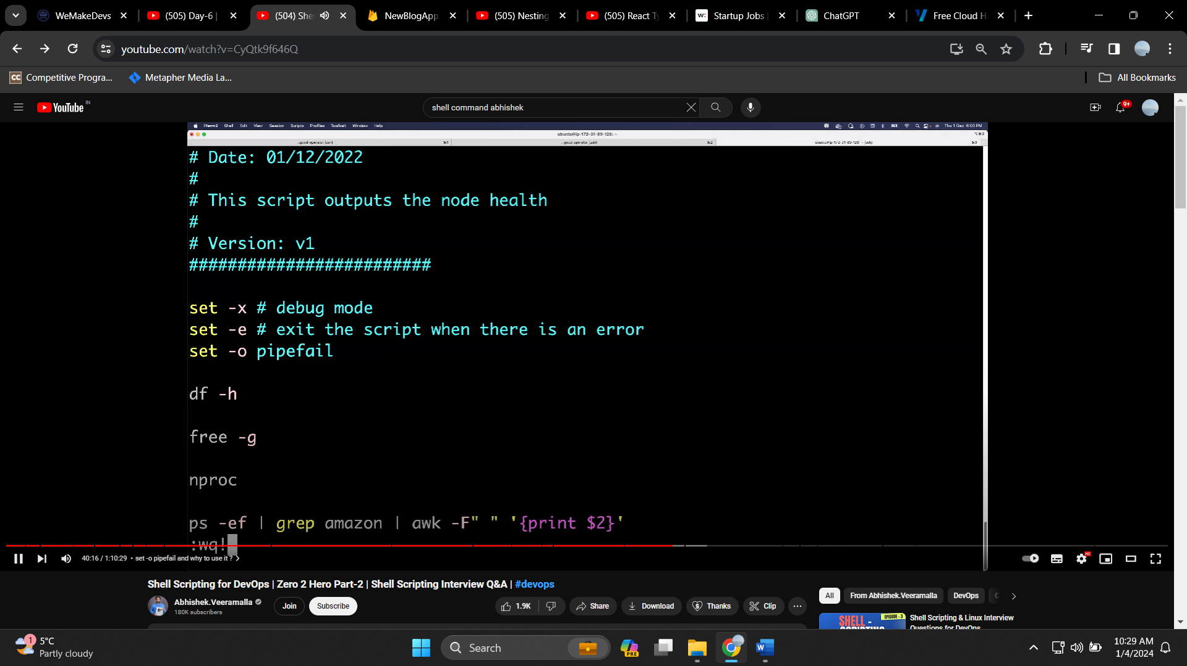

***Curl command***

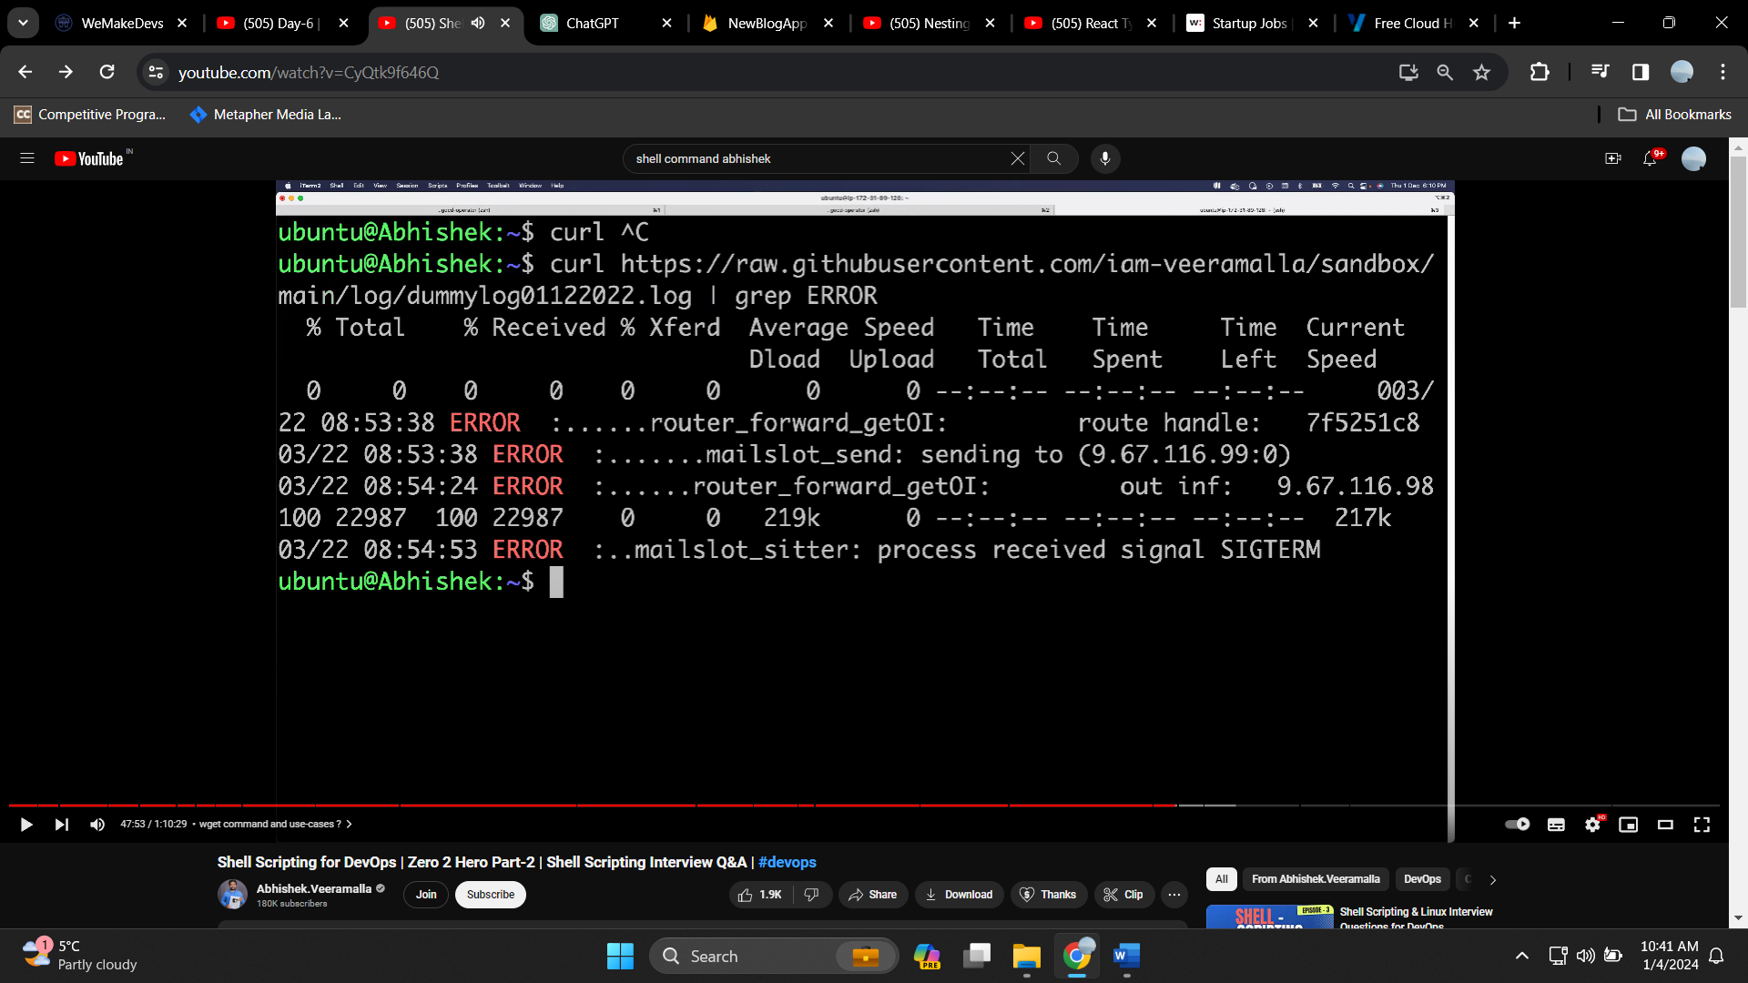

***Wget command***

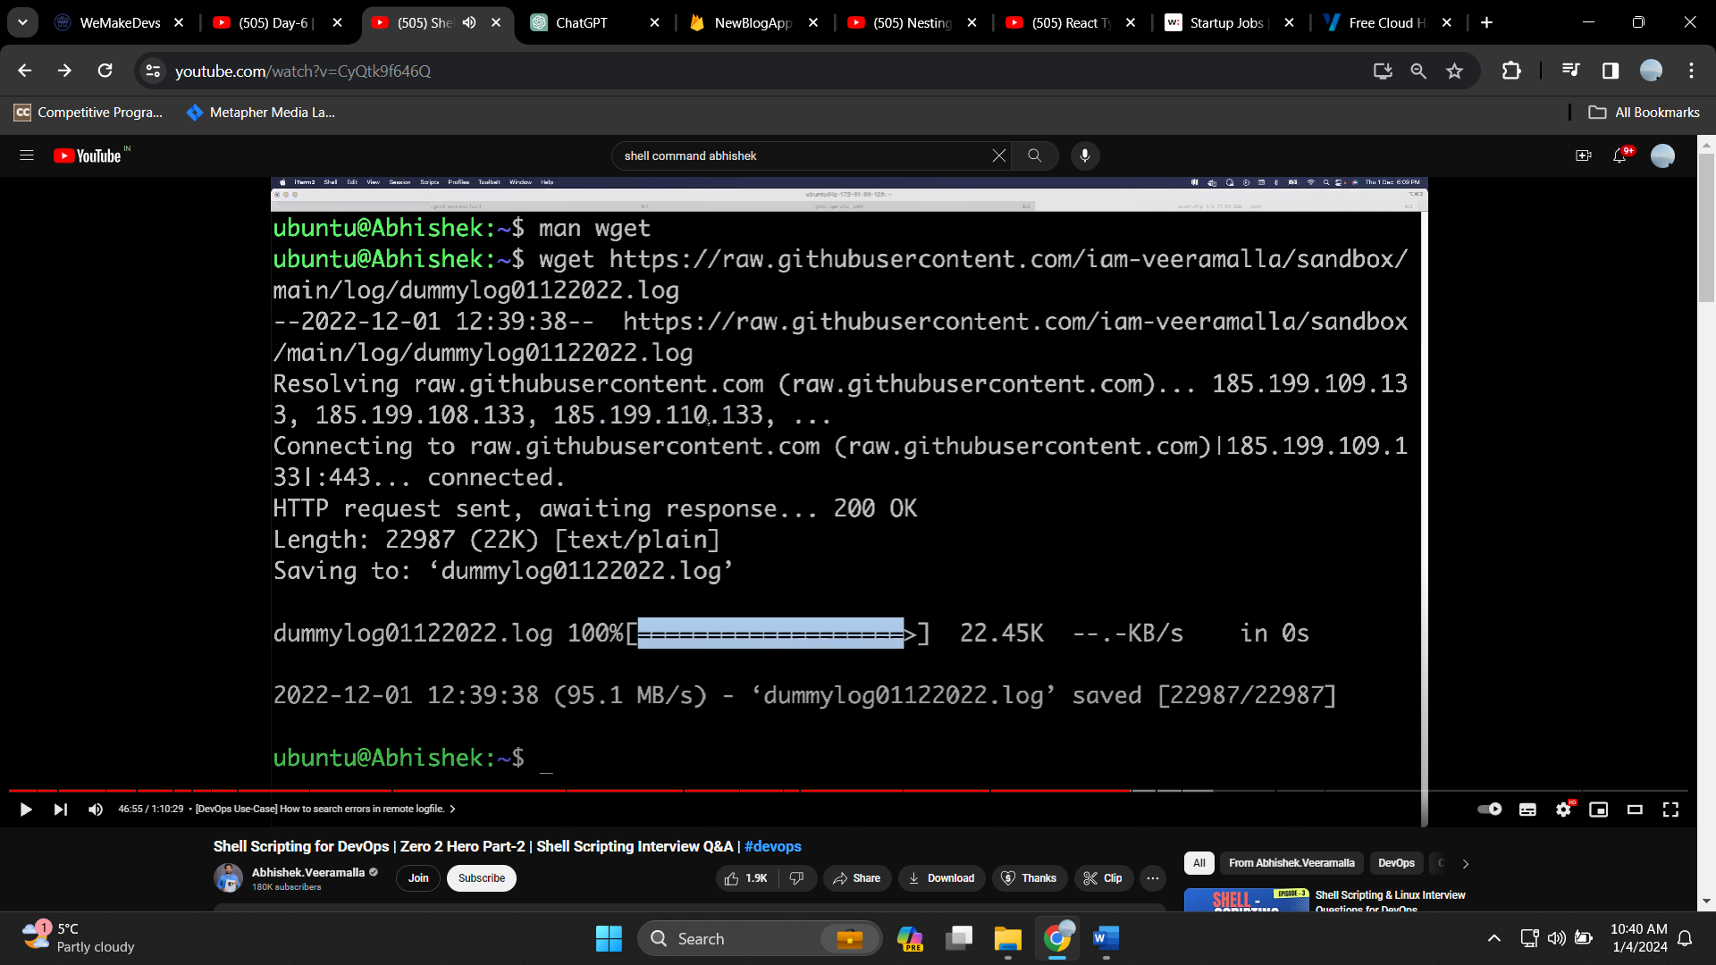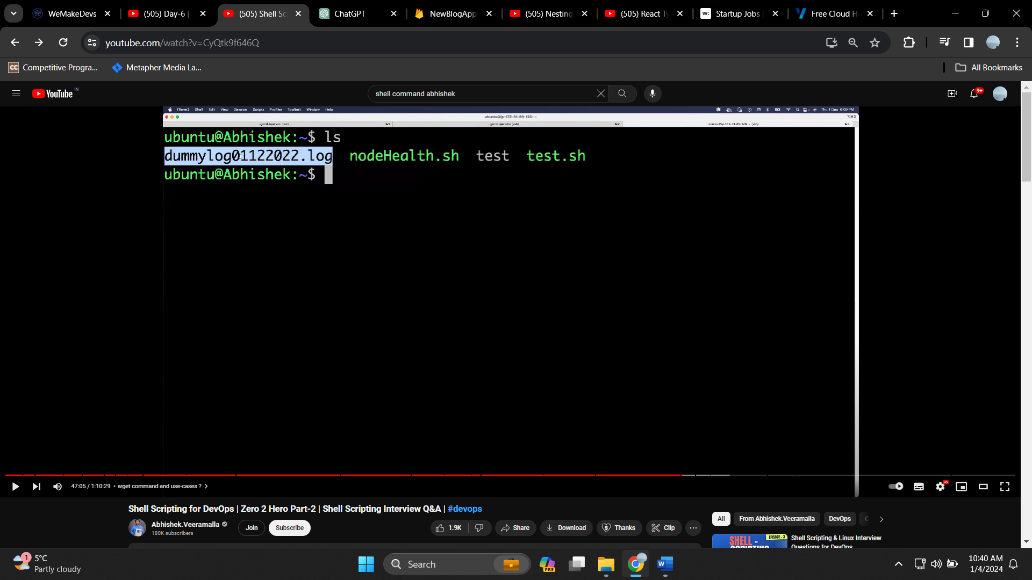

***Now project of shell***

***Jq is used to find and print out the specific its like destructuring***

Use of jq 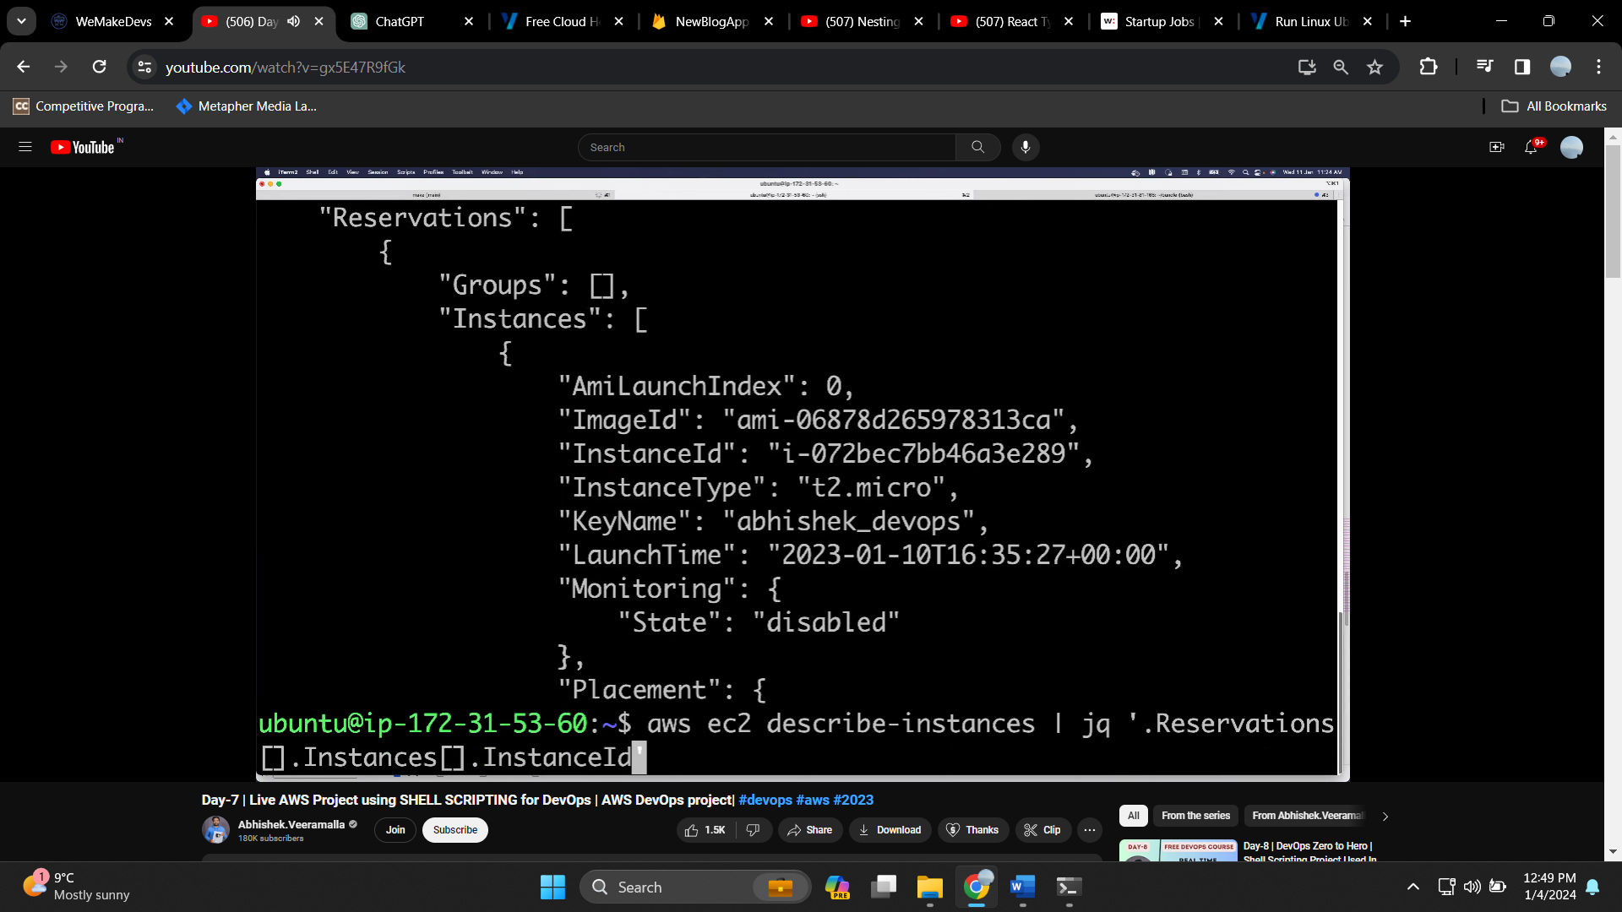 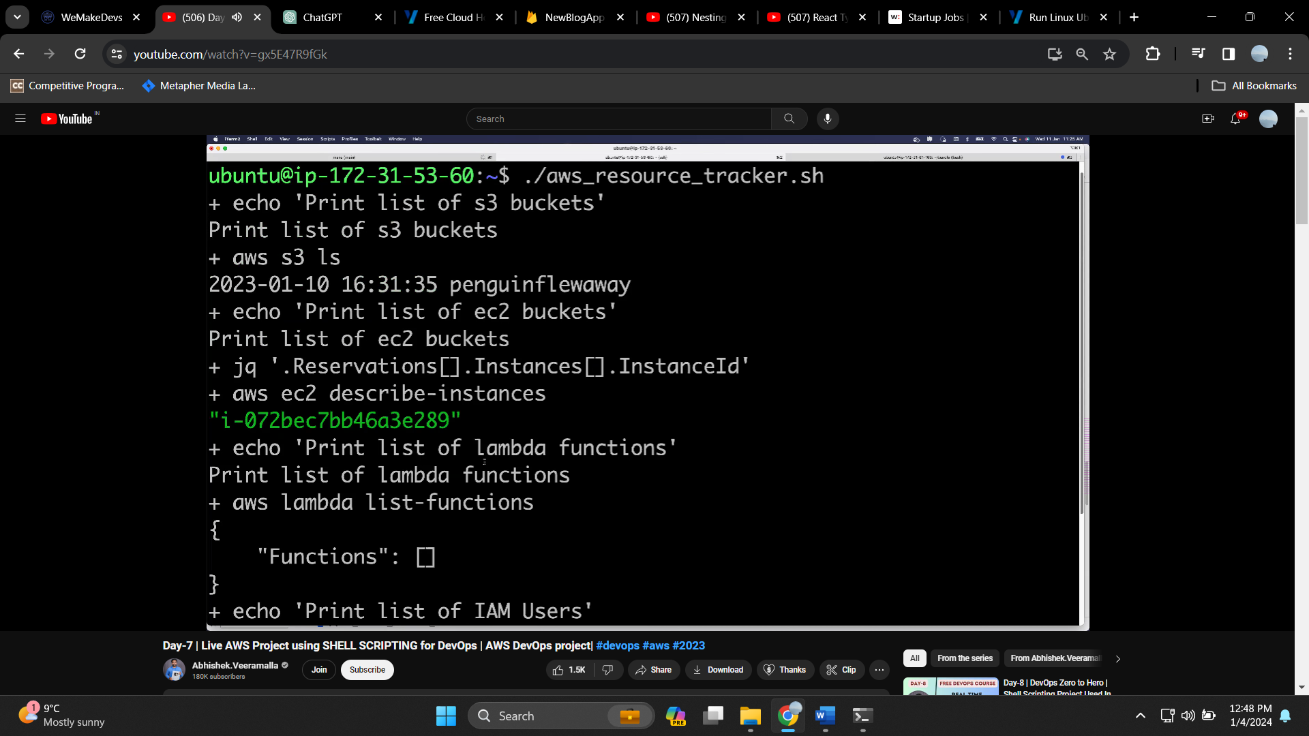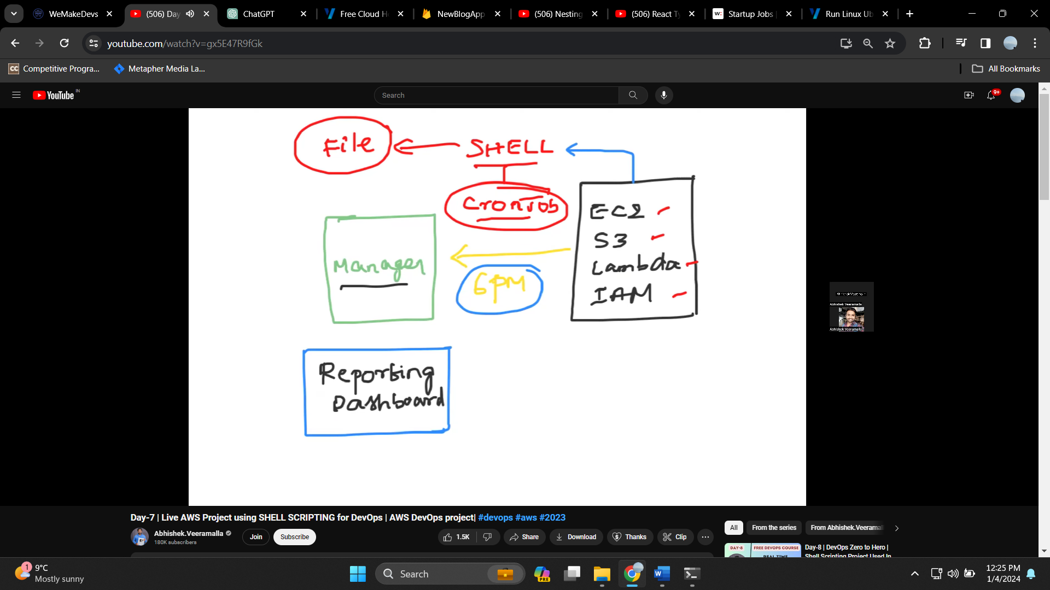







***Ansible***

**first install ansible In the root instance . then create keypair in it using ssh-keygen**

**then copy the content of the public key from this**

**go to the target instance , there you should also do ssh-keygen**

**then in the authorized key that is generated , paste the key from the root instance**

**just like shell file hota hai , isi way may ansible ma playbooks hota hai AND just like we can directly execute the command without even generating the shell file we can also execute in the ansible. First one is called adhoc command and second one is called the playbook (in which we write the commands that are very large in number )**

